# List Methods Confusion

Below are some notes about the difference between .append, .extend, direct assignment, and += when it comes to lists.

**(1)** Using .append will mutate the list.

lst1 = [1, 2]  
lst2 = lst1  
lst1.append(3)

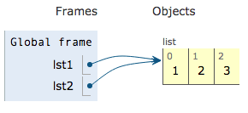

Note that lst1 and lst2 still point to the same list.

**(2)** Using .extend will also mutate the list.

lst1 = [1, 2]  
lst2 = lst1  
lst1.extend([3])



Note that lst1 and lst2 still point to the same list.

**(3)** Using direct assignment will change the reference.

lst1 = [1, 2]  
lst2 = lst1  
lst1 = lst1 + [3]

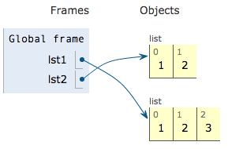

Note that lst1 and lst2 point to different lists.

**(4)** += is not the same as the previous example, and actually mutates the list.

lst += lst2 is equivalent with lst.extend(lst2)

lst1 = [1, 2]  
lst2 = lst1  
lst1 += [3]

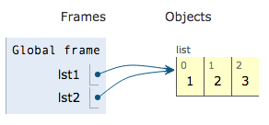

Note that lst1 and lst2 still point to the same list.

**What you should know**

You should understand the environment diagrams for (1), (2) and (3), and why the environment diagrams are displayed as they are. You do not need to understand why (4) does not behave the same as (3), but you should know that the difference exists so that you don’t run into issues concerning this difference when you are coding.